I. INTRODUCTION
1.1 Overview
A power quality problem is defined as any variation in voltage, current or frequency that may lead to an equipment failure or malfunction. In a modern electrical distribution system, there has been a sudden increase of nonlinear loads, such as power supplies, rectifier equipment used in telecommunication networks, domestic appliances, adjustable speed drives, etc. These power-electronic-based loads offer highly nonlinear characteristics.
Due to their non-linearity, the loads are simultaneously the major causes and the major victims of power quality problems. Harmonics, voltage sag/swell and persistent quasi steady state harmonics and dynamic switching excursions can result in electric equipment failure, malfunction, hot neutral, ground potential use, fire and shock hazard in addition to poor power factor and inefficient utilization of electric energy manifested in increase reactive power supply to the hybrid load, poor power factor and severely distorted voltage and current waveforms. To improve the efficiency, capacitors are employed which also leads to the improvement of power factor of the mains.
Passive filters are traditionally used to absorb harmonic currents because of low cost and simple robust structure. But they provide fixed compensation and create system resonance . The filtering characteristics of passive filters are determined by the impedance ratio of the supply and the passive filter and are often difficult to design.
The shunt active filters are used for providing compensation of harmonics, reactive power and/or neutral current in ac networks, regulation of terminal voltage, suppression of the voltage flicker, and to improve voltage balance in three phase system.
They have the capability of damping harmonic resonance between an existing passive filter and the supply impedance, but they require a large current rating with high current bandwidth and do not constitute a cost-effective harmonic filtering solution for nonlinear loads.
Hybrid filters effectively mitigate the problems of both passive filters and pure active filter solutions and provide cost effective and practical harmonic compensation approach, particularly for high power nonlinear loads.
The combination of low cost passive filters and control capability of small rating active filter effectively improve the compensation characteristics of passive filters and hence reduce the rating of the active filters, compared to pure shunt or series active filter solutions.
Many power filter compensation configurations are proposed in literature to enhance power quality and to improve power factor .The paper validated a novel modulated power filter compensator (MPFC) scheme, designed by the First Author, to improve the power quality and utilization in smart grid application.
The proposed FACTS based system utilizes the tri-loop dynamic error-driven modified PID controller to control the MPFC. The proposed scheme proved success in improving the power quality, enhancing power factor, reduce transmission losses and limit transient over voltage and inrush current conditions
For distribution system the power flow analysis is a very important and fundamental tool. Its results play the major role during the operational stages of any system for its control and economic schedule, as well as during expansion and design stages.
The purpose of any load flow analysis is to compute precise steady-state voltages and voltage angles of all buses in the network, the real and reactive power flows into every line and transformer, under the assumption
of known generation and load.
During the second half of the twentieth century, and after the large technological developments in the fields of digital computers and high-level programming languages, many methods for solving the load flow problem have been developed, such as Gauss-Siedel (bus impedance matrix), Newton-Raphson’s (NR) and its decoupled versions. Nowadays, many improvements have been added to all these methods involving assumptions and approximations of the transmission lines and bus data, based on real systems conditions.
The Fast Decoupled Power Flow Method (FDPFM) is one of these improved methods, which was based on a simplification of the Newton-Raphson’s method and reported by Stott and Alsac in 1974. This method due to its calculations simplifications, fast convergence and reliable results became the most widely used method in load flow analysis. However, FDPFM for some cases, where high R/X ratios or heavy loading (Low Voltage) at some buses are present, does not converge well. For these cases, many efforts and developments have been made to overcome these convergence obstacles. Some of them targeted the convergence of systems with high R/X ratios, others those with low voltage buses. Though many efforts and elaborations have been achieved in order to improve the FDPFM, this method can still attract many researchers, especially when computers and simulations are becoming more developed and are now able to handle and analyze large size system.
Power must be available to the consumers in any amount that they may require from time to time. For example, motors may be started or shut down, lights may be turned on or off, without advance warning to the electric supply company.
As electrical energy cannot be stored, therefore, the distribution system must be capable of supplying load demands of the consumers. This necessitates that operating staff must continuously study load patterns to predict in advance those major load changes that follow the known schedules.

II. Literature Survey
A.M. Sharaf,Hong Huang and Liuchen chang Proc of the IEEE Inter Symp.
on Industrial Electronics, pp 616-621, 1995 described regarding power quality and nonlinear load voltage stabilization using error-driven switched passive power filter. The paper presents an error –driven rule based control system for passive power filter switching to enhance power quality and reduce voltage flickering.The scheme extends the functionality of a fixed passive power filter by modulating the filtering action using a solid state switching converter.
Hideaki fujitha and Hirofuni Akagi IEEE Trans. Ind. Applicat., vol.
27, no. 6, pp.1020–1025, Nov./Dec. 1991.described a Practical approach to harmonic compensation in power systems series connection of passive and active filters. This paper presents a combined system of a passive filter and a small rated active filter, both connected in series with each other. The passive filter removes load produced harmonics just as a conventional one does. On the other hand ,the active filter plays a role in improving the filtering characteristics of the passive filter.This results in a great reduction of the required rating of the active filter and in eliminating all the limitations faced by using only the passive filter, leading to a practical and economical system.
Adel M.Sharaf and Guoshang wang proceedings of the IEEE International Conference on Electrical, Electronic and Computer Engineering. pp. 804-807, 5-7 Sept. 2004. described regarding wind energy system voltage and energy enhancement using low cost dynamic capacitor compensation scheme. The paper presents a novel low cost dynamic capacitor compensation scheme using real time dynamic error tracking and harmonic ripple based PID controller to stabilize an isolated stand alone wind energy conversion scheme (WECS) with a induction generator. The novel dynamic capacitor compensation scheme serves as a voltage stabilization regulator and utilization enhancement compensator.
Adel M Sharaf,Weihua wang,Ismail H Altas International Journal of Emerging Electric Power Systems. Vol. 8, Issue 3, Article 6, Aug. 2007.IEEE CCECE described regarding a novel modulated power filter compensator for distribution networks with distributed wind energy. This paper is about the integration of dispersed renewable wind energy will pose a great challenge to the power quality in the distribution networks when the weak nature of the grid in remote areas and the uncertainity of wind are taken into consideration. This paper presents a novel MPFC for the distribution networks with dispersed renewable wind energy interfaced. A tri loop error driven controller is used to adjust the PWM switching of the modulated power filter compensator. Full power factor correction and power quality improvement is validated under different operation conditions like load switching and wind velocity excursions.

III. Problem Formulation
A power quality problem is defined as any variation in voltage, current or frequency that may lead to an equipment failure or malfunction. In a modern electrical distribution system, there has been a sudden increase of nonlinear loads, such as power supplies, rectifier equipment used in telecommunication networks, domestic appliances, adjustable speed drives, etc. These power-electronic based loads offer highly nonlinear characteristics. Due to their non-linearity ,the loads are simultaneously the major causes and the major victims of power quality problems. Harmonics, voltage sag/swell and persistent quasi steady state harmonics and dynamic switching excursions can result in electric equipment failure, malfunction, hot neutral, ground potential use, fire and shock hazard in addition to poor power factor and inefficient utilization of electric energy manifested in increase reactive power supply to the hybrid load, poor power factor and severely distorted voltage and current waveforms. To improve the dynamic behavior of different types of loads by improving the power quality. The cases include i) Normal operating condition ii) Short circuit condition iii) Hybrid load excursion case with MPFC and without MPFC.

IV. Objective of the Thesis
To improve the efficiency, capacitors are employed which also leads to the improvement of power factor of the mains. Passive filters are traditionally used to absorb harmonic currents because of low cost and simple robust structure. But they provide fixed compensation and create system resonance. The filtering characteristics of passive filters are determined by the impedance ratio of the supply and the passive filter are often difficult to design. The shunt active filters are used for providing compensation of harmonics, reactive power and neutral current in ac networks, regulation of terminal voltage, suppression of the voltage flicker, and to improve voltage balance in three phase system. They have the capability of damping harmonic resonance between an existing passive filter and the supply impedance, but they require a large current rating with high current bandwidth and do not constitute a cost effective harmonic filtering solution for nonlinear loads. Hybrid filters effectively mitigate the problems of both passive and pure active filter solutions and provide cost effective and practical harmonic compensation approach, particularly for high power nonlinear loads.
The works aims at the improvement of power quality by voltage stabilization, power factor correction, transmission line loss reduction. To improve the power quality modulated power filter compensator (MPFC) scheme is used for the smart grid stabilization and efficient utilization. The MPFC is controlled by a novel tri-loop dynamic error driven inter coupled modified PID controller.
4.1 Organization Of Thesis
In Chapter 1 gives the introduction and overview of the project.
In Chapter 5 deals with power quality problems and benefits of power quality improvement and equipment reliability.
In Chapter 6 demonstrates the effectiveness of active filters, their classification, applications and briefs about harmonic compensation.
In Chapter 7 The flexible AC systems types and explanation about FACTS controller is given.
In Chapter 8 presents a comprehensive description of voltage source inverter and pulse width modulation (PWM) technique.
In Chapter 9 The system used for the investigations conducted in this thesis is described and the detailed models are presented.
In Chapter 10 presents the simulation results of the case study and summarizes the work and present conclusions.

V. POWER QUALITY
5.1 Introduction
The contemporary container crane industry, like many other industry segments, is often enamored by the bells and whistles, colorful diagnostic displays, high speed performance, and levels of automation that can be achieved. Although these features and their indirectly related computer based enhancements are key issues to an efficient terminal operation, we must not forget the foundation upon which we are building. Power quality is the mortar which bonds the foundation blocks. Power quality also affects terminal operating economics, crane reliability, our environment, and initial investment in power distribution systems to support new crane installations. To quote the utility company newsletter which accompanied the last monthly issue of my home utility billing: ‘Using electricity wisely is a good environmental and business practice which saves you money, reduces emissions from generating plants, and conserves our natural resources.’ As we are all aware, container crane performance requirements continue to increase at an astounding rate. Next generation container cranes, already in the bidding process, will require average power demands of 1500 to 2000 kW – almost double the total average demand three years ago. The rapid increase in power demand levels, an increase in container crane population, SCR converter crane drive retrofits and the large AC and DC drives needed to power and control these cranes will increase awareness of the power quality issue in the very near future.
5.2 POWER QUALITY PROBLEMS
For the purpose of this article, we shall define power quality problems as:
‘Any power problem that results in failure or misoperation of customer equipment manifests itself as an economic burden to the user, or produces negative impacts on the environment.’
When applied to the container crane industry, the power issues which degrade power quality include:
  - Power Factor
  - Harmonic Distortion
  - Voltage Transients
  - Voltage Sags or Dips
  - Voltage Swells
The AC and DC variable speed drives utilized on board container cranes are significant contributors to total harmonic current and voltage distortion.
Whereas SCR phase control creates the desirable average power factor, DC SCR drives operate at less than this. In addition, line notching occurs when SCR’s commutate, creating transient peak recovery voltages that can be 3 to 4 times the nominal line voltage depending upon the system impedance and the size of the drives. The frequency and severity of these power system disturbances varies with the speed of the drive. Harmonic current injection by AC and DC drives will be highest when the drives are operating at slow speeds. Power factor will be lowest when DC drives are operating at slow speeds or during initial acceleration and deceleration periods, increasing to its maximum value when the SCR’s are phased on to produce rated or base speed. Above base speed, the power factor essentially remains constant. Unfortunately, container cranes can spend considerable time at low speeds as the operator attempts to spot and land containers. Poor power factor places a greater KVA demand burden on the utility or engine-alternator power source. Low power factor loads can also affect the voltage stability which can ultimately result in detrimental effects on the life of sensitive electronic equipment or even intermittent malfunction. Voltage transients created by DC drive SCR line notching, AC drive voltage chopping, and high frequency harmonic voltages and currents are all significant sources of noise and disturbance to sensitive electronic equipment. It has been our experience that end users often do not associate power quality problems with Container cranes, either because they are totally unaware of such issues or there was no economic Consequence if power quality was not addressed. Before the advent of solid-state power supplies, Power factor was reasonable, and harmonic current injection was minimal. Not until the crane Population multiplied, power demands per crane increased, and static power conversion became the way of life, did power quality issues begin to emerge. Even as harmonic distortion and power Factor issues surfaced, no one was really prepared.
Even today, crane builders and electrical drive System vendors avoid the issue during competitive bidding for new cranes. Rather than focus on Awareness and understanding of the potential issues, the power quality issue is intentionally or unintentionally ignored. Power quality problem solutions are available. Although the solutions are not free, in most cases, they do represent a good return on investment. However, if power quality is not specified, it most likely will not be delivered.
Power quality can be improved through:
  - Power factor correction,
  - Harmonic filtering,
  - Special line notch filtering,
  - Transient voltage surge suppression,
  - Proper earthing systems.
In most cases, the person specifying and/or buying a container crane may not be fully aware of the potential power quality issues. If this article accomplishes nothing else, we would hope to provide that awareness.
In many cases, those involved with specification and procurement of container cranes may not be cognizant of such issues, do not pay the utility billings, or consider it someone else’s concern. As a result, container crane specifications may not include definitive power quality criteria such as power factor correction and/or harmonic filtering. Also, many of those specifications which do require power quality equipment do not properly define the criteria. Early in the process of preparing the crane specification:
  - Consult with the utility company to determine regulatory or contract requirements that must be satisfied, if any.
  - Consult with the electrical drive suppliers and determine the power quality profiles that can be expected based on the drive sizes and technologies proposed for the specific project.
  - Evaluate the economics of power quality correction not only on the present situation, but consider the impact of future utility deregulation and the future development plans for the terminal
5.3 THE BENEFITS OF POWER QUALITY
Power quality in the container terminal environment impacts the economics of the terminal operation, affects reliability of the terminal equipment, and affects other consumers served by the same utility service. Each of these concerns is explored in the following paragraphs.
It has been our experience that end users often do not associate power quality problems with Container cranes, either because they are totally unaware of such issues or there was no economic Consequence if power quality was not addressed. Before the advent of solid-state power supplies, Power factor was reasonable, and harmonic current injection was minimal. Not until the crane Population multiplied, power demands per crane increased, and static power conversion became the way of life, did power quality issues begin to emerge. Even as harmonic distortion and power Factor issues surfaced, no one was really prepared.
Even today, crane builders and electrical drive System vendors avoid the issue during competitive bidding for new cranes. Rather than focus on Awareness and understanding of the potential issues, the power quality issue is intentionally or unintentionally ignored. Power quality problem solutions are available. Although the solutions are not free, in most cases, they do represent a good return on investment. However, if power quality is not specified, it most likely will not be delivered. It has been our experience that end users often do not associate power quality problems with Container cranes, either because they are totally unaware of such issues or there was no economic Consequence if power quality was not addressed. Before the advent of solid-state power supplies, Power factor was reasonable, and harmonic current injection was minimal. Not until the crane Population multiplied, power demands per crane increased, and static power conversion became the way of life, did power quality issues begin to emerge. Even as harmonic distortion and power Factor issues surfaced, no one was really prepared.
Even today, crane builders and electrical drive System vendors avoid the issue during competitive bidding for new cranes. Rather than focus on Awareness and understanding of the potential issues, the power quality issue is intentionally or unintentionally ignored. Power quality problem solutions are available. Although the solutions are not free, in most cases, they do represent a good return on investment. However, if power quality is not specified, it most likely will not be delivered.
5.4 SUMMARY
It has dealt with power quality problems and benefits of power quality improvement.

VI. ACTIVE POWER FILTERS
6.1 INTRODUCTION
Active Filters are commonly used for providing harmonic compensation to a system by controlling current harmonics in supply networks at the low to medium voltage distribution level or for reactive power or voltage control at high voltage distribution level. These functions may be combined in a single circuit to achieve the various functions mentioned above or in separate active filters which can attack each aspect individually.
The block diagram presented in section shows the basic sequence of 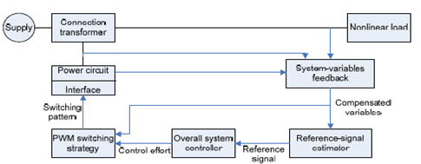
Fig 6.1 Generalized block diagram of active filter
operation for the active filter. This diagram shows various sections of the filter each responding to its own classification.
6.2 CLASSIFICATION OF ACTIVE FILTERS
The block diagram shown in figure represents the key components of a typical active power filter along with their interconnections. The reference signal estimator monitors the harmonic current from the nonlinear load along with information about other system variables. The reference signal from the current estimator, as well as other signals, drives the overall system controller. This in turn provides the control for the PWM switching pattern generator. The output of the PWM pattern generator controls the power circuit through a suitable interface. The power circuit in the generalized block diagram can be connected in parallel, series or parallel/series configurations, depending on the transformer used.
Active power filters according to can be classified based on the following criteria:
  - Power rating and speed of response required in compensated systems
  - Power-circuit configuration and connections
  - System parameters to be compensated
  - Control techniques employed
  - Technique used for estimating the reference current/voltage.
The block diagram shown in figure shows the classification based on this criterion.
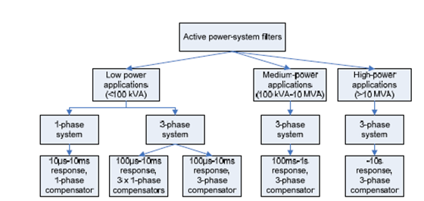
Fig 6.2 Sub division of active filter according to speed response and power rating

6.2.1 Low Power Applications
Low power applications govern applications with a power rating below 100kVA. Applications of these sizes are generally associated with residential areas, commercial buildings, hospitals and for a wide range of medium sized factory loads and motor drive systems. Active filters chosen for this power range employ sophisticated techniques catering with high pulse number PWM voltage or current source inverters.
The response time for smaller applications is relatively much faster than other sizes ranging from ten microseconds to ten milliseconds. This type comprises the following two categories.
6.2.2 Medium Power Applications
Power systems ranging between 100kVA to 10MVA fit the class of a medium power application. Due to the fact that phase unbalances are reduced on this sized system, the major objective is to eliminate current harmonics.
In general, capacitive and Inductive static compensators, line-commutated thyristor converters, synchronous condensers and cascaded multilevel-inverter VAR compensators, are often more economic as reactive power compensation using active filters often is not viable. This is due to the high voltage as well as problems with isolation and series/parallel connection of switches. The speed of response expected in this range is of the order of tens of milliseconds.
6.2.3 High Power Applications
At high power ratings, the use of active filters becomes very uneconomical. This is because of the lack of high switching frequency power devices that can control the current flow. Thus, this is a major disadvantage for such systems. In addition, even the latest advances in semiconductor technology still fall short as extra high voltages of a few hundred kilovolts cannot be tolerated. The series-parallel combination is possible however; implementation is difficult and also cost-ineffective. Harmonic pollution upstream affecting high power ranges above 10MVA is not such a problem compared against low power systems.
6.3 SHUNT ACTIVE FILTERS
Shunt active filters are by far the most widely accept and dominant filter of choice in most industrial processes. Figures show the system configuration of the shunt design. The active filter is connected in parallel at the PCC and is fed from the main power circuit. The objective of the shunt active filter is to supply opposing harmonic current to the nonlinear load effectively resulting in a net harmonic current.
This means that the supply signals remain purely fundamental. Shunt filters also have the additional benefit of contributing to reactive power compensation and balancing of three-phase currents. Since the active filter is connected in parallel to the PCC, only the compensation current plus a small amount of active fundamental current is carried in the unit. For an increased range of power ratings, several shunt active filters can be combined together to withstand higher currents. This configuration consists of four distinct categories of circuit, namely inverter configurations, switched-capacitor circuits, lattice-structured filters and voltage-regulator-type
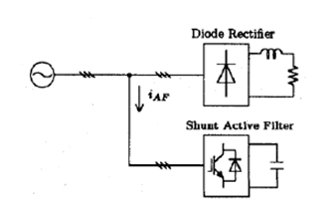
Fig 6.3 Shunt active filter alone-

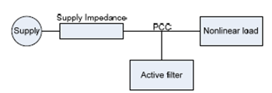
Fig 6.4 Shunt active filter network configuration
6.4 SERIES ACTIVE FILTERS
The objective of the series active filter is to maintain a pure sinusoidal voltage waveform across the load. This is achieved by producing a PWM voltage waveform which is added or subtracted against the supply voltage waveform. The choice of power circuit used in most cases is the voltage-fed PWM inverter without a current minor loop.
The active filter acts as a voltage source and thus it is often a preferred solution of harmonic producing loads such as large capacity diode rectifiers with capacitive loads. In general, series active filters are less commonly used against the shunt design. Unlike the shunt filter which carries mainly compensation current, the series circuit has to handle high load currents. This causes an increased rating of the filter suitable to carry the increased current. Series filters offer the main advantage over the shunt configuration of achieving ac voltage regulation by eliminating voltage-waveform harmonics. This means the load contains a pure sinusoidal waveform.
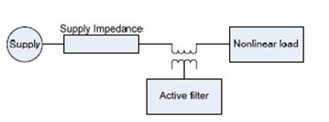
Fig 6.5 Series active filter configuration.
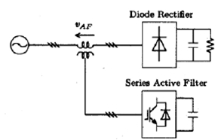
Fig 6.6 Series active filter alone

6.5 OTHER COMBINATIONS
In some cases, the combinations of shunt and series active filters provide a greater effectiveness in eliminating harmonic pollution from the system.

6.5.1 Combination of Both Shunt and Series Active Filters
The diagram shown in figure shows the combination of both parallel and series active filters. This system combines both the benefits of the shunt and series and is often used to achieve the demanding power system requirements. The control of active filters can be complex. A combination of the two provides an even greater complexity. The higher cost involved in a more complex design has shown a reduced demand for the combined structure. As a result of the increased cost and complexity, this combination has received less attention than other configurations. Flexible AC transmission systems, commonly abbreviated as FACTS regularly make use of the arrangement
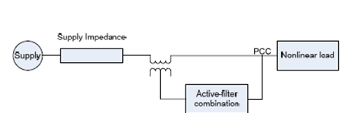
Fig 6.7 Combination of shunt and series filter

6.5.2 Combination of Series Active and Shunt Passive Filters
The combination of the active parallel and active series filters is seen to be very complex in control yielding a high cost. One method of reducing these problems was to replace the parallel active filter with a passive structure. The series active filter, which constitutes high impedance for high-frequency harmonics, is accompanied by a parallel passive filter to provide a path for the harmonic currents of the load. This combination, represented by figure, permits an improvement over the characteristics of plain series active filters and the extension of their capabilities to include current- harmonic reduction and voltage- harmonic elimination. Passive filters are often easier and simple to implement and do not require any control circuit. This, this deserves to be most beneficial.

6.5.3 Combination Of Shunt Active And Passive Filters
Shunt active filters are best suitable to compensate for lower order harmonics thus only requiring low power rating which serves most economical. This configuration makes use of a passive filter which serves to compensate for the high order load current harmonics.
This combination, represented by figure presents this important configuration. Combinations such as this can be designed to compensate for higher powers without excessive costs for high-power switching.
The major disadvantage of this configuration is the fact that passive filters can only be tuned for a specific predefined harmonic and thus cannot be easily changed for loads which have varying harmonics.
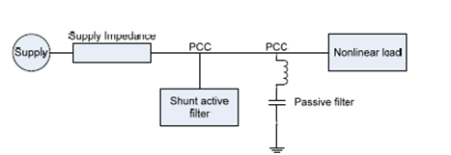
Fig 6.8 combination of shunt active and passive filters
6.5.4 Active Filter in Series With Shunt Passive Filters
The combination of an active filter in series with a shunt passive filter is considered a significant design configuration for medium and high voltage applications. The passive filter is designed to reduce the voltage stress applied to the switches in the active filter. This design is in its infancy of development however, further research is still needed to assess the effectiveness of the configuration.

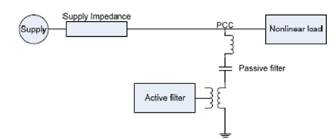
Fig 6.9 Active filter in series with the passive filter
6.6 HARMONIC COMPENSATION
Within the system, active filters can be used to provide suitable harmonic compensation for voltage harmonics and current harmonics. These harmonic are the most important variable requiring compensation.
6.6.1 Compensation of Voltage Harmonics
In general, the concern for compensating voltage harmonics is not high due to the fact that power supplies usually have low impedance. Generally, at the point of common coupling, ridged standards are implemented to ensure a correct level of total harmonic distortion (THD) and voltage regulation is maintained. The problem of compensating for voltage harmonics is to ensure the supply to be purely sinusoidal.
This is important for harmonic voltage sensitive devices such as power system protection devices and superconducting magnetic energy storage. Voltage harmonics are related to current harmonics by the impedance of the line. Although compensation of voltage harmonics helps to provide a reduction in current harmonics, this however, does not negate the necessity to current harmonic compensation.
6.6.2 Compensation of Current Harmonics
Current harmonic compensation strategies are exceptionally important. Current harmonics are greatly reduced by the compensation of voltage harmonics at the consumer’s point of common coupling. The reduction in current harmonics is not only important for reasons such as device heating and reduction in life of devices but also in design of power system equipment. One of the major design criteria covers the magnitude of the current and its waveform. This is to reduce cable and feeder losses. Since the Vrms, root mean square (RMS) of the load current incorporates the sum of squares of individual harmonics, true current harmonic compensation will aid system designers for better approached power rating equipment.
6.7 BALANCING OF THREE PHASE SYSTEMS
In most low and medium voltage distribution systems, it is frequent to find situations where the currents and voltages in the three phases are not balanced and are not evenly distributed by 120 degrees.
6.7.1 Balancing Of Mains Voltage in Three Phase Systems
Voltage imbalance is a situation where each phase voltage is unequal in magnitude and is not displaced by 120 degrees. This is a direct result of current imbalances and the severity of the system imbalances is governed by the magnitude of the supply impedance. The solution to this problem is to add or subtract the corresponding amount of instantaneous voltage to force it to follow the reference sinusoidal waveform. On high voltage systems, the supply impedance does not impact severely on system performance and thus the problem of mains voltage unbalances are primarily related to low rating systems.
6.7.2 Balancing Of Mains Current In Three Phase Systems
In low power applications such as compensating for residential loads, the magnitude of currents supplied to the grid depends entirely upon the level of imbalance in the system. In most cases, the compensator would be forced to supply rated current. This places a limitation on the power handling capability.
6.8 MULTIPLE COMPENSATION
To target a variety of variables requiring compensation, often it is usual to combine different combinations to improve the effectiveness of the filter. The following are the most frequently used combinations.
6.8.1 Harmonic Current With Reactive Power Compensation
One very common filter design makes use of combining aspects of reactive power compensation together with harmonic current elimination. This ensures the supply current remains purely fundamental free from distributing harmonics whilst making certain the current is in phase with the supply voltage. This approach is very cost effective because only one device is used for all aspects rather than including multiple circuits for each individual objective. The active filter used here however, suffers from poor power switching limits and thus can only serve as a compensator for low powered applications.
6.8.2 Harmonic Voltages With Reactive Power Compensation
This combination, however rare, takes place in certain configurations for controlling the voltage harmonics, which would normally affect indirectly (using suitable feedback) the reactive-power compensation. This compensation system is only suitable for low-power applications.
6.8.3 Harmonic Current and Voltages
To compensate for both current and voltage system harmonics, a shunt and series active filter configuration must be used respectively. Integrating this filter serves to eliminate load harmonics whilst ensuring the supply remains fundamental. This type of design contains very complex control algorithms and is normally used only for very sensitive devices such as power-system-protection equipment and superconducting magnetic-energy storage systems.
6.8.4 Harmonic Current and Voltages With Reactive Power Compensation
This filter design incorporates all three compensating variables into one unit. It controls all harmonics and reactive power within the system. This is achieved by implementing of a parallel/series active filter combination. The control for this design is very complex and difficult to maintain and thus is not often employed.
6.9 SUMMARY
It has demonstrated the effectiveness of active power filters, their classification, and applications and have presented about harmonic compensation.
VII. FLEXIBLE AC TRANSMISSION SYSTEM (FACTS)
7.1 INTRODUCTION
Flexible AC Transmission Systems, called FACTS, got in the recent years a well known term for higher controllability in power systems by means of power electronic devices. Several FACTS-devices have been introduced for various applications worldwide. A number of new types of devices are in the stage of being introduced in practice.
In most of the applications the controllability is used to avoid cost intensive or landscape requiring extensions of power systems, for instance like upgrades or additions of substations and power lines. FACTS-devices provide a better adaptation to varying operational conditions and improve the usage of existing installations.
The basic applications of FACTS-devices are:
- Power flow control,
- increase of transmission capability,
- voltage control,
- reactive power compensation,
- stability improvement,
- power quality improvement,
- power conditioning,
- flicker mitigation,
- Interconnection of renewable and distributed generation and storages.
Figure shows the basic idea of FACTS for transmission systems. The usage of lines for active power transmission should be ideally up to the thermal limits. Voltage and stability limits shall be shifted with the means of the several different FACTS devices. It can be seen that with growing line length, the opportunity for FACTS devices gets more and more important.
The influence of FACTS-devices is achieved through switched or controlled shunt compensation, series compensation or phase shift control. The devices work electrically as fast current, voltage or impedance controllers. The power electronic allows very short reaction times down to far below one second.
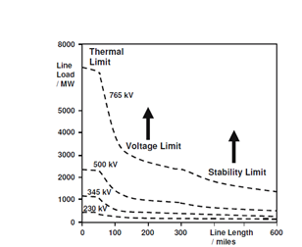
Fig 7.1 Operational limits of transmission lines for different voltage levels
The development of FACTS-devices has started with the growing capabilities of power electronic components. Devices for high power levels have been made available in converters for high and even highest voltage levels. The overall starting points are network elements influencing the reactive power or the impedance of a part of the power system.
7.2 CONFIGURATIONS of FACTS-Devices
7.2.1 Shunt Devices
The most used FACTS-device is the SVC or the version with Voltage Source Converter called STATCOM. These shunt devices are operating as reactive power compensators. The main applications in transmission, distribution and industrial networks are:
- Reduction of unwanted reactive power flows and therefore reduced network losses.
- Keeping of contractual power exchanges with balanced reactive power.
- Compensation of consumers and improvement of power quality especially with huge demand fluctuations like industrial machines, metal melting plants, railway or underground train systems.
- Compensation of Thyristor converters e.g. in conventional HVDC lines.
- Improvement of static or transient stability.
Almost half of the SVC and more than half of the STATCOMs are used for industrial applications. Industry as well as commercial and domestic groups of users require power quality. Flickering lamps are no longer accepted, nor are interruptions of industrial processes due to insufficient power quality. Railway or underground systems with huge load variations require SVCs or STATCOMs.
7.2.1.1 Applications Of The SVC Systems In Transmission Systems
Electrical loads both generate and absorb reactive power. Since the transmitted load varies considerably from one hour to another, the reactive power balance in a grid varies as well. The result can be unacceptable voltage amplitude variations or even a voltage depression, at the extreme a voltage collapse.
A rapidly operating Static Var Compensator (SVC) can continuously provide the reactive power required to control dynamic voltage oscillations under various system conditions and thereby improve the power system transmission and distribution stability.
Applications of the SVC systems in transmission systems:
a. To increase active power transfer capacity and transient stability margin
b. To damp power oscillations
c. To achieve effective voltage control
In addition, SVCs are also used
1. In transmission systems
a. To reduce temporary over voltages
b. To damp sub synchronous resonances
c. To damp power oscillations in interconnected power systems
2. In traction systems
a. To balance loads
b. To improve power factor
c. To improve voltage regulation
3. In HVDC systems
a. To provide reactive power to ac–dc converters
4. In arc furnaces
a. To reduce voltage variations and associated light flicker
Installing an SVC at one or more suitable points in the network can increase transfer capability and reduce losses while maintaining a smooth voltage profile under different network conditions. In addition an SVC can mitigate active power oscillations through voltage amplitude modulation.

Fig 7.2 SVC building blocks and voltage / current characteristic
7.2.2 STATCOM
In 1999 the first SVC with Voltage Source Converter called STATCOM (Static Compensator) went into operation. The STATCOM has a characteristic similar to the synchronous condenser, but as an electronic device it has no inertia and is superior to the synchronous condenser in several ways, such as better dynamics, a lower investment cost and lower operating and maintenance costs. A STATCOM is build with Thyristors with turn-off capability like GTO or today IGCT or with more and more IGBTs. The static line between the current limitations has a certain steepness determining the control characteristic for the voltage.
The advantage of a STATCOM is that the reactive power provision is independent from the actual voltage on the connection point.
This can be seen in the diagram for the maximum currents being independent of the voltage in comparison to the SVC. This means, that even during most severe contingencies, the STATCOM keeps its full capability.
In the distributed energy sector the usage of Voltage Source Converters for grid interconnection is common practice today. The next step in STATCOM development is the combination with energy storages on the DC-side. The performance for power quality and balanced network operation can be improved much more with the combination of active and reactive power.
Fig 7.3 STATCOM structure and voltage / current characteristic
7.2.3 SERIES DEVICES
Series devices have been further developed from fixed or mechanically switched compensations to the Thyristor Controlled Series Compensation (TCSC) or even Voltage Source Converter based devices.
The main applications are:
- Reduction of series voltage decline in magnitude and angle over a power line,
- Reduction of voltage fluctuations within defined limits during changing power transmissions,
- Improvement of system damping resp. damping of oscillations,
- Limitation of short circuit currents in networks or substations,
- Avoidance of loop flows resp. power flow adjustments.
7.2.3.1 Thyristor Controlled Series Capacitors (TCSC):
Thyristor Controlled Series Capacitors (TCSC) address specific dynamical problems in transmission systems. Firstly it increases damping when large electrical systems are interconnected. Secondly it can overcome the problem of Sub Synchronous Resonance (SSR), a phenomenon that involves an interaction between large thermal generating units and series compensated transmission systems.
The TCSC's high speed switching capability provides a mechanism for controlling line power flow, which permits increased loading of existing transmission lines, and allows for rapid readjustment of line power flow in response to various contingencies. The TCSC also can regulate steady-state power flow within its rating limits.
The TSSC can control the degree of series compensation by either inserting or by passing series capacitors, but it can’t change the natural characteristics of the classical series capacitor compensated line. The pure TSSC would not b e used in critical applications, where a high degree of compensation is required and the danger of sub synchronous resonance is present. Nevertheless, the TSSC could be applied for power flow control and for damping power oscillation, where the required speed of response is moderate.
A thyristor valve commutates “naturally”, thus a capacitor is inserted into the line by the thyristor valve at the zero crossings of the line current. Since the insertion takes place at line current zero, a full half-cycle of the line current will charge the capacitor from zero to maximum, opposite polarity half cycle of the line current will discharge it from maximum to zero.
Fig 7.4 Thyristor Controlled Series Capacitors
7.2.3.2 Thyristor-Switched Series Capacitor (TSSC)
The basic circuit arrangement of the thyristor-switched series capacitor is shown in Figure 7.4.1.
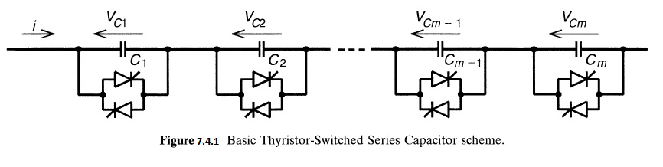It consists of a number of capacitors, each shunted by an appropriately rated bypass valve composed of a string of reverse parallel connected thyristors, in series. As seen, it is similar to the circuit structure of the sequentially operated GCSC shown in Figure 7.4.2,
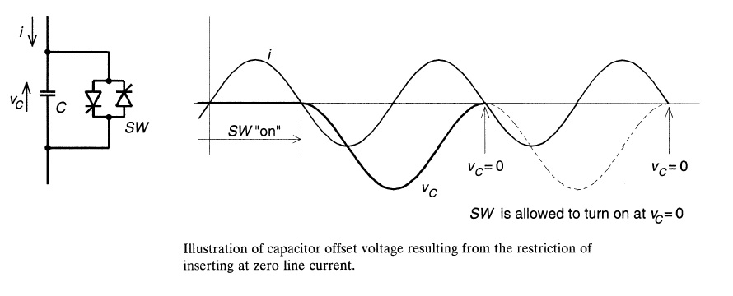
but its operation is different due to the imposed switching restrictions of the conventional thyristor valve. The operating principle of the TSSC is straightforward: the degree of series compensation is controlled in a step-like manner by increasing or decreasing the number of series capacitors inserted. A capacitor is inserted by turning off, and it is bypassed by turning on the corresponding thyristor valve. A thyristor valve commutates "naturally," that is, it turns off when the current crosses zero. Thus a capacitor can be inserted into the line by the thyristor valve only at the zero crossings of the line current.
In order to minimize the initial surge current in the valve, and the corresponding circuit transient, the thyristor valve should be turned on for bypass only when the capacitor voltage is zero. With the prevailing dc offset, this requirement can cause a delay of up to one full cycle, which would set the theoretical limit for the attainable response time of the TSSC. The TSSC can control the degree of series compensation by either inserting or bypassing series capacitors but it cannot change the natural characteristic of the classical series capacitor compensated line. This means that a sufficiently high degree of TSSC compensation could cause subsynchronous resonance just as well as an ordinary capacitor. In principle, the TSSC switching could be modulated to counteract subsynchronous oscillations. However, considering the relatively long switching delays en- countered, the modulation is likely to be ineffective, if not counterproductive, except for the very low end of the subsynchronous frequency band.
The basic V-I characteristic of the TSSC with four series connected compensator modules operated to control the compensating voltage is shown in Figure 7.4.3.
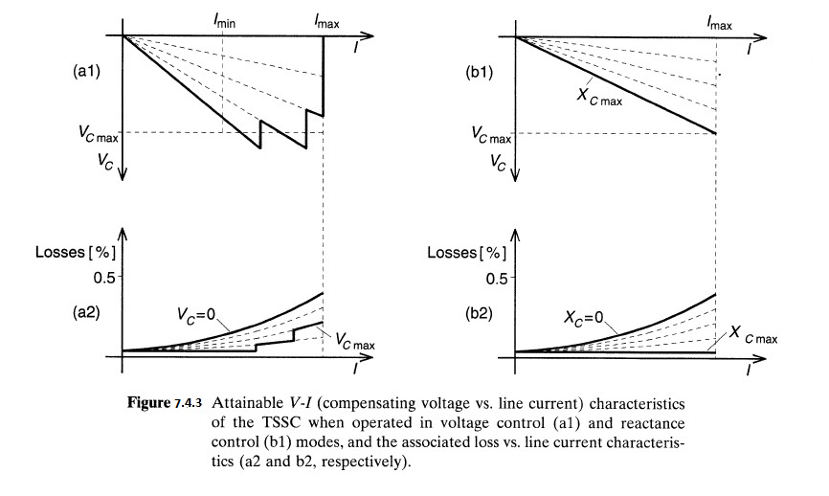
For this compensating mode the reactance of the capacitor banks is chosen so as to produce, on the average, the rated compensating voltage, , in the face of decreasing line current over a defined interval. As the current is increased toward , the capacitor banks are progressively bypassed by the related thyristor valves to reduce the overall capacitive reactance in a step-like manner and thereby maintain the compensating voltage with increasing line current.
7.3 SUMMARY
It has given the detailed study of the flexible transmission AC systems types and have explained about FACTS controllers.

VIII. VOLTAGE SOURCE INVERTER
8.1 INTRODUCTION
Single-phase voltage source inverters (VSIs) can be found as half-bridge and full-bridge topologies. Although the power range they cover is the low one, they are widely used in power supplies, single-phase UPSs, and currently to form elaborate high-power static power topologies, such as for instance, the multi cell configurations that are reviewed in Section. The main features of both approaches are reviewed and presented in the following.
8.2 Pulse width Modulation (pwm)
Pulse Width Modulation (PWM) is the most effective means to achieve constant voltage battery charging by switching the solar system controller’s power devices. When in PWM regulation, the current from the solar array tapers according to the battery’s condition and recharging needs consider a waveform such as this: it is a voltage switching between 0v and 12v. It is fairly obvious that, since the voltage is at 12v for exactly as long as it is at 0v, then a 'suitable device' connected to its output will see the average voltage and think it is being fed 6v - exactly half of 12v. So by varying the width of the positive pulse - we can vary the 'average' voltage V_{av}.
Similarly, if the switches keep the voltage at 12 for 3 times as long as at 0v, the average will be 3/4 of 12v - or 9v, as shown below and if the output pulse of 12v lasts only 25% of the overall time, then the average is
Fig 8.1 Pulse width modulation
By varying - or 'modulating' V_{c} - the time that the output is at 12v (i.e. the width of the positive pulse) we can alter the average voltage. So we are doing 'pulse width modulation'. As said earlier that the output had to feed 'a suitable device'. A radio would not work from this: the radio would see 12v then 0v, and would probably not work properly. However a device such as a motor will respond to the average, so PWM is a natural for motor control.
8.3 Pulse Width modulator
So, how do we generate a PWM waveform? It's actually very easy, first you generate a triangle waveform as shown in the diagram below. You compare this with a dc voltage, which you adjust to control the ratio of on to off time that you require. When the triangle is above the 'demand' voltage, the output goes high. When the triangle is below the demand voltage, the
Fig 8.2 Output of a Comparator
When the demand speed it in the middle (A) you get a 50:50 output, as in black. Half the time the output is high and half the time it is low. Fortunately, there is an IC (Integrated circuit) called a comparator: these come usually 4 sections in a single package. One can be used as the oscillator to produce the triangular waveform and another to do the comparing, so a complete oscillator and modulator can be done with half an IC and maybe 7 other bits.
The triangle waveform, which has approximately equal rise and fall slopes, is one of the commonest used, but you can use a saw tooth (where the voltage falls quickly and rises slowly). You could use other waveforms and the exact linearity (how good the rise and fall are) is not too important.
Traditional solenoid driver electronics rely on linear control, which is the application of a constant voltage across a resistance to produce an output current that is directly proportional to the voltage. Feedback can be used to achieve an output that matches exactly the control signal. However, this scheme dissipates a lot of power as heat, and it is therefore very inefficient.
A more efficient technique employs pulse width modulation (PWM) to produce the constant current through the coil. A PWM signal is not constant. Rather, the signal is on for part of its period, and off for the rest. The duty cycle, D, refers to the percentage of the period for which the signal is on. The duty cycle can be anywhere from 0, the signal is always off, to 1, where the signal is constantly on. A 50% D results in a perfect square wave

Fig 8.3 Duty Cycle

8.4 SUMMARY
It has presented a comprehensive description of voltage source inverter and pulse width modulation technique.

IX. MODELLING OF CASE STUDY
9.1 INTRODUCTION
The low cost modulated dynamic series-shunt power filter and compensator is a switched type filter, used to provide measured filtering in addition to reactive compensation. The modulated power filter and compensator is controlled by the on-off timing sequence of the pulse width modulation (PWM) switching pulses that are generated by the dynamic tri loop error driven dynamic modified PID controller. The modified PID controller is equipped with a supplementary error-sequenced compensation loop for fast effective dynamic response in addition to conventional PID activation
Fig 9.1 Modified Power Filter Compensator structure
This scheme of MPFC s tructure comprises a series fixed capacitor bank and two shunt fixed capacitor banks are connected to a modulated PWM switched tuned arm filter through six pulse uncontrolled rectifier. The MATLAB model of this scheme structure is shown Fig 9.1.
9.2 TRI LOOP ERROR DRIVEN MODIFIED PID CONTROLLER
The tri-loop error-driven dynamic controller is a novel dual action control used to modulate the power filter compensator. The global error signal is an input to the modified PID controller to regulate the modulating control signal to the PWM switching block as shown. The modified PID includes an error sequential activation supplementary loop to ensure fast dynamic response and affective damping of large excursion, in addition to conventional PID Structure
Fig 9.2 Modified tri loop error driven PID controller
Fig 9.3 MATLAB functional model of the Inter-coupled tri loop error driven modified PID controller
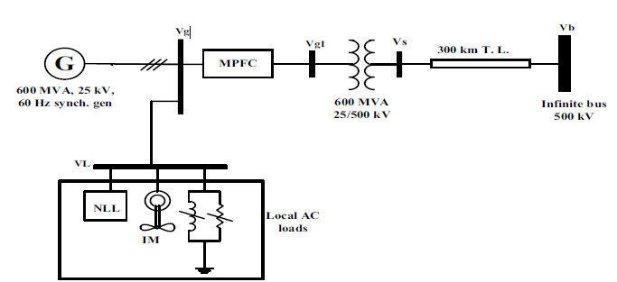
Fig 9.4 The single line diagram of the unified EHV study AC system

9.3 SUMMARY:
It has shown the system used for the investigations conducted in this thesis is described and the detailed models are presented
X. MATLAB DESIGN OF CASE STUDY AND RESULTS
10.1 INTRODUCTION
The dynamic responses of voltage, current, reactive power, power factor, THD of voltage, THD of current at generator bus Vg, load bus VL and infinite bus Vb under normal operation, short circuit fault condition and hybrid local load excursion cases with MPFC and without MPFC are shown. The modulated tuned power filter switching signals that are generated by the dynamic tri loop error driven dynamic modified PID controller are shown. The stable voltage signal of synchronous generator power system stabilization (PSS) is shown. The Transmission line losses are shown.
10.2 Block diagram of Normal Loading Operation WITHOUT MPFC AND WITH MPFC
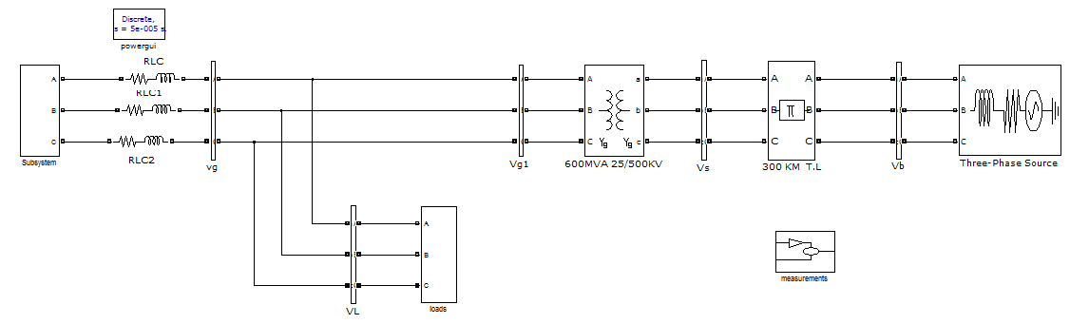 Fig 10.1 Block Diagram of Normal Loading Operation Case without MPFC

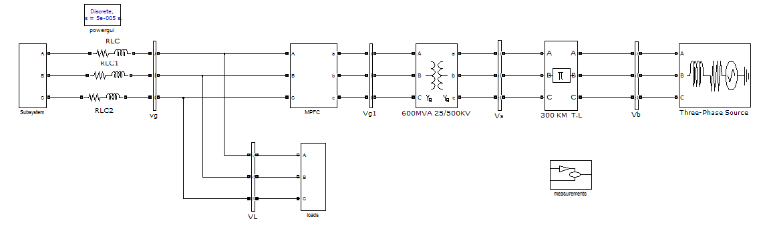 Fig 10.2 Block Diagram of Normal Loading Operation Case with MPFC

10.3 SIMULATION RESULTS OF NORMAL LOADING OPERATION CASE WITHOUT MPFC AND WITH MPFC
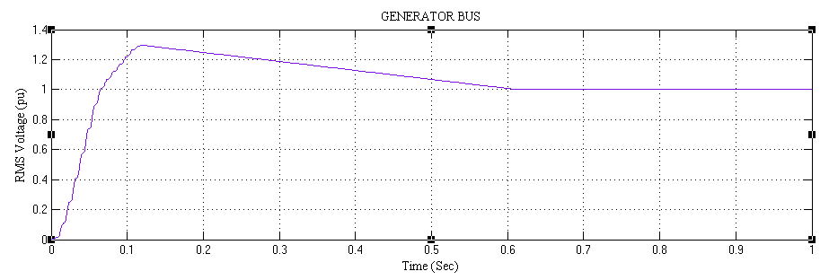 Fig 10.3 The RMS voltage at Generator bus without MPFC
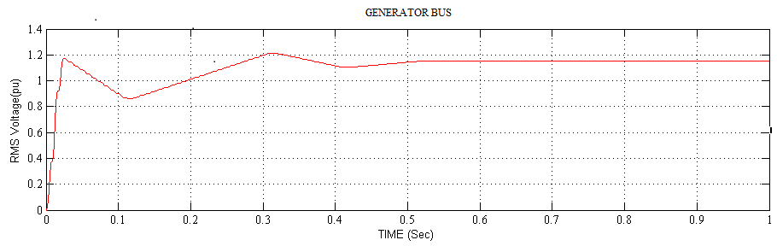 Fig 10.4 The RMS voltage at Generator bus with MPFC

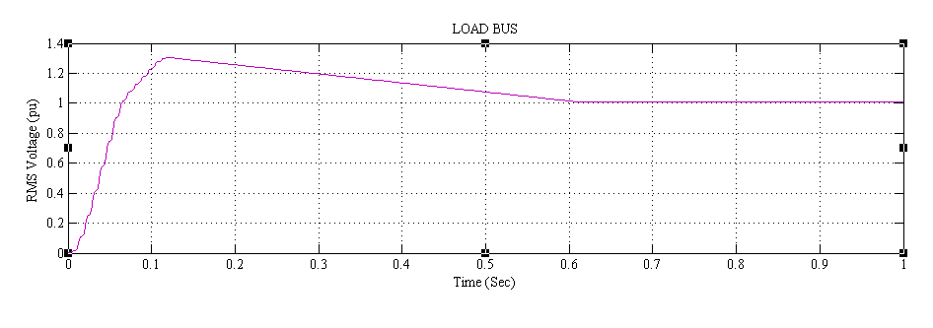Fig 10.5 The RMS voltage at Load bus without MPFC
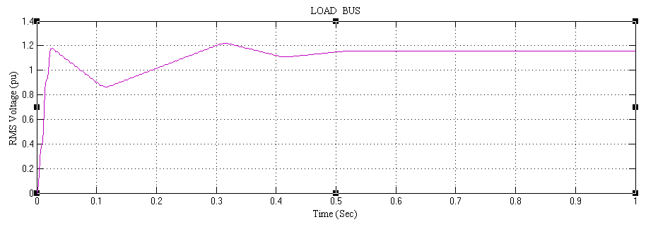 Fig 10.6 The RMS voltage at Load bus with MPFC
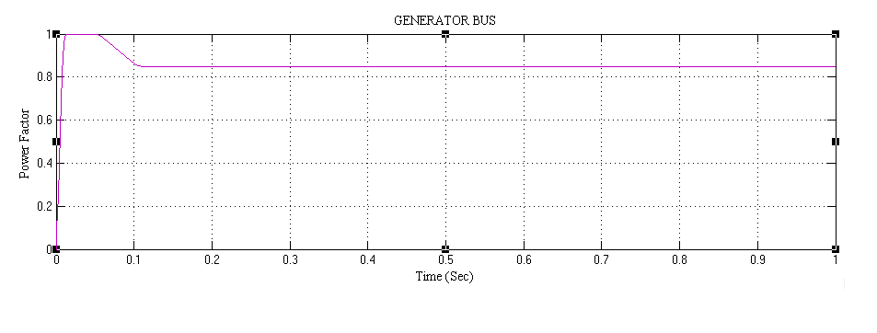Fig 10.7 The power factor at Generator bus without MPFC
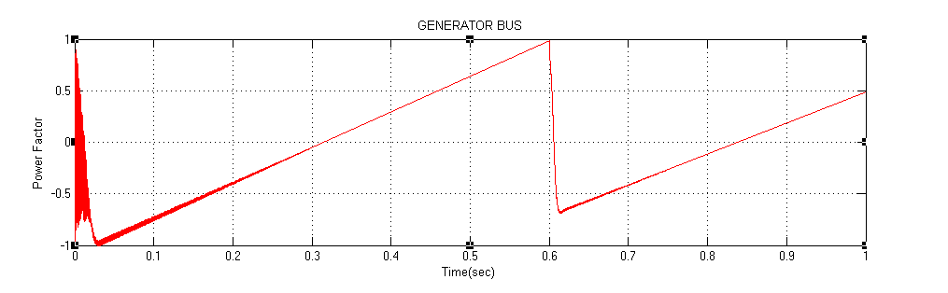
Fig 10.8 The power factor at Generator bus with MPFC
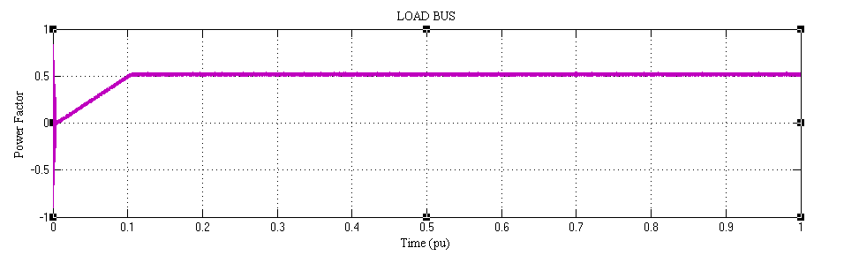
Fig 10.9 The power factor at Load bus without MPFC
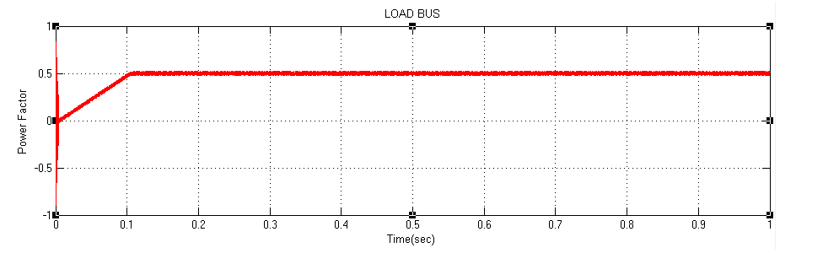
Fig 10.10 The power factor at Load bus with MPFC
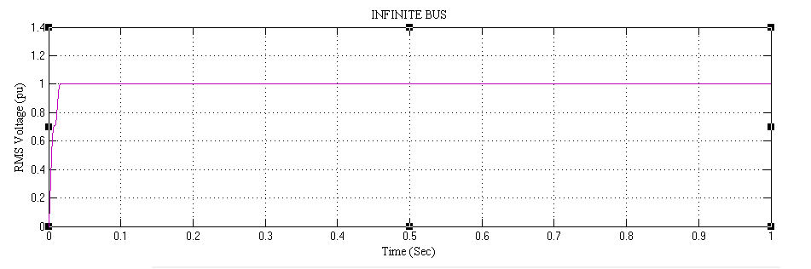
Fig 10.11 The RMS voltage at the infinite bus without MPFC
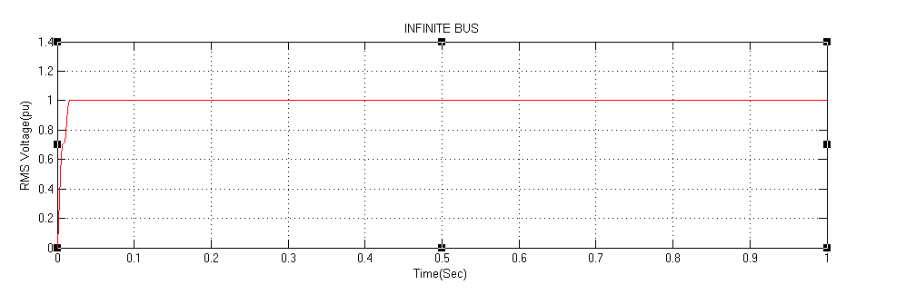 Fig 10.12 The RMS voltage at the infinite bus with MPFC
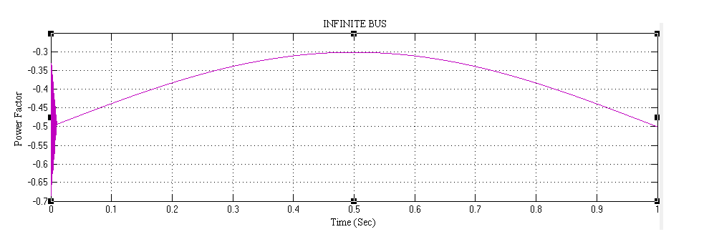 Fig 10.13 The power factor at the infinite bus without MPFC
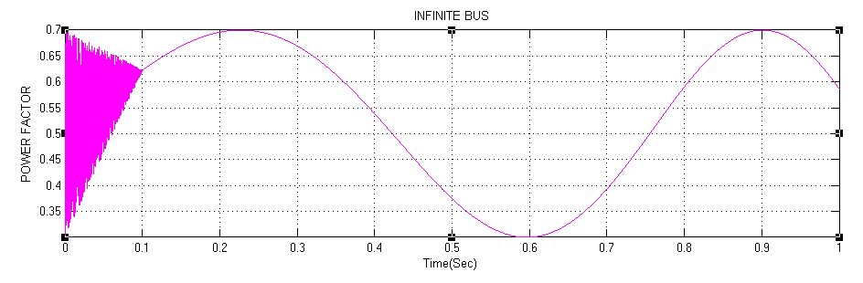
Fig 10.14 The power factor at the infinite bus with MPFC

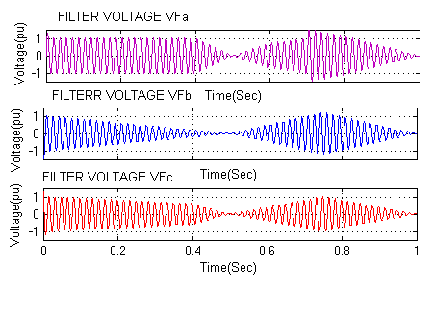
Fig 10.15 The voltage waveforms of MPFC

10.4 BLOCK DIAGRAM OF SHORT CIRCUIT FAULT CONDITION WITHOUT MPFC AND WITH MPFC:
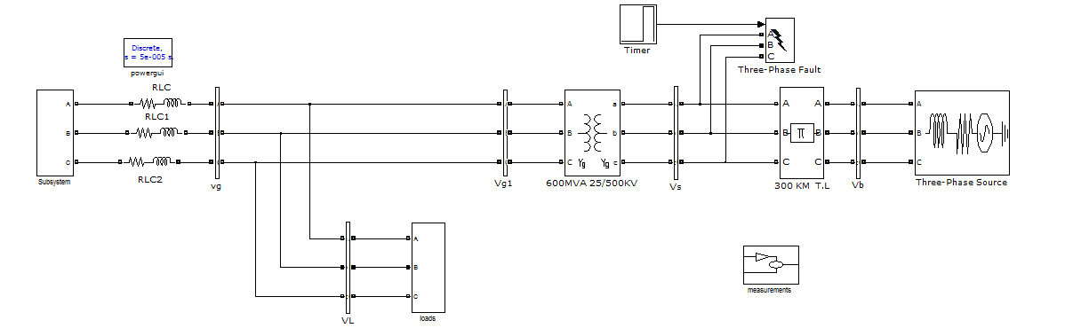Fig 10.16 Block Diagram of Short Circuit Fault Condition Case without MPFC

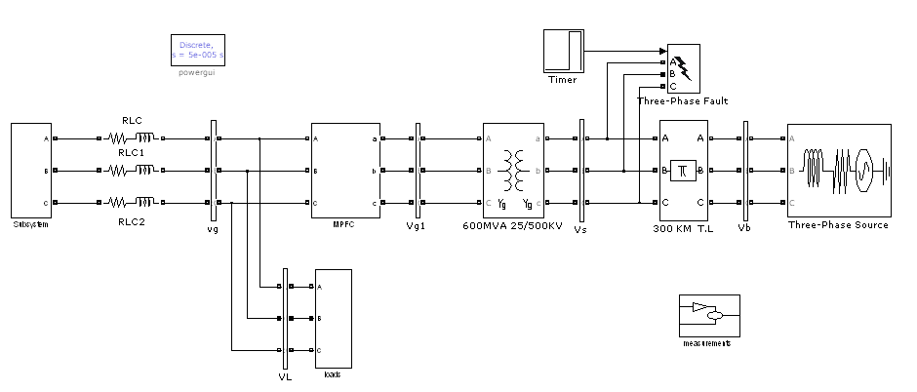 Fig 10.17 Block Diagram of Short Circuit Fault Condition Case with MPFC

10.5 SIMULATION RESULTS OF SHORT CIRCUIT FAULT CONDITION CASE WITHOUT MPFC AND WITH MPFC
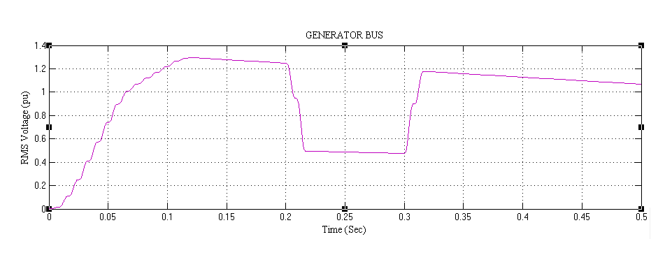 Fig 10.18 The RMS voltage at generator bus without MPFC
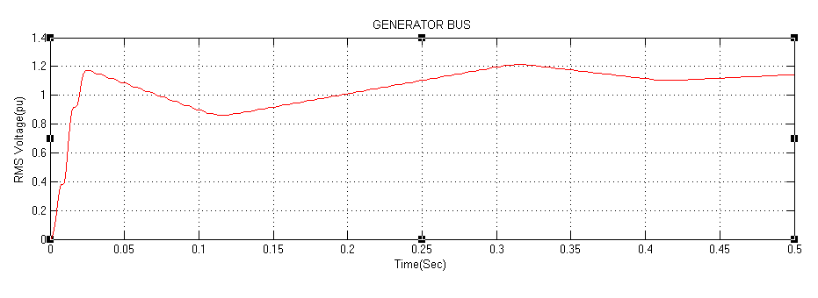
Fig 10.19 The RMS voltage at generator bus with MPFC
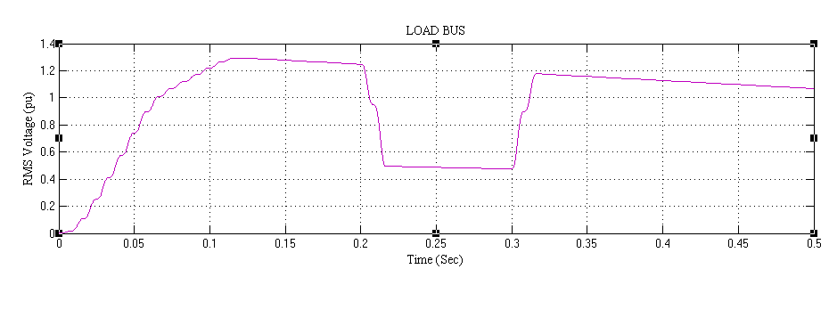 Fig 10.20 The RMS voltage at Load bus without MPFC

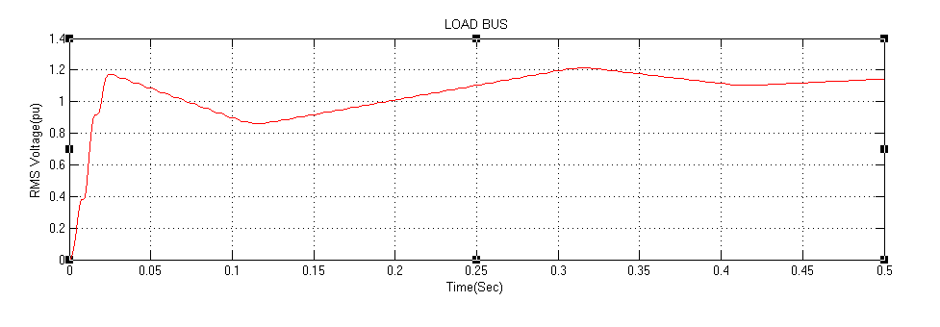
Fig 10.21 The RMS voltage at Load bus with MPFC

10.6 BLOCK DIAGRAM OF HYBRID LOCAL LOAD EXCURSION CASE WITHOUT MPFC AND WITH MPFC
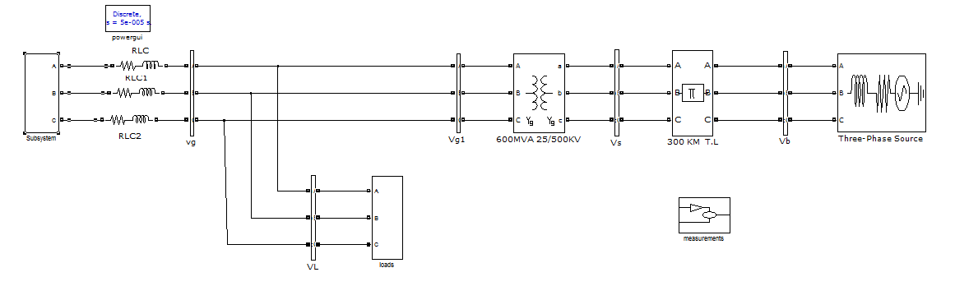 Fig 10.22 Block Diagram of Hybrid Local Load Excursion Case without MPFC
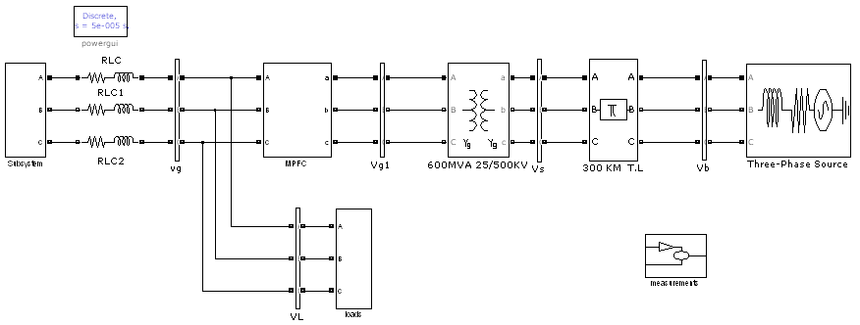 Fig 10.23 Block Diagram of Hybrid Local Load Excursions Case with MPFC

10.7 SIMULATION RESULTS OF HYBRID LOCAL LOAD EXCURSION CASE WITHOUT MPFC AND WITH MPFC
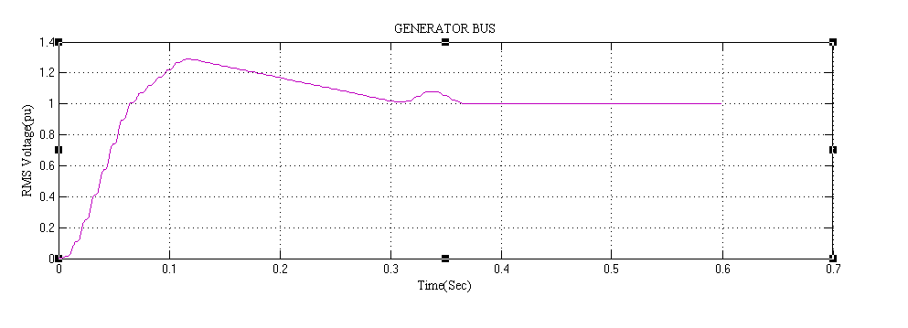 Fig 10.24 The RMS voltage waveform at the generator bus without MPFC
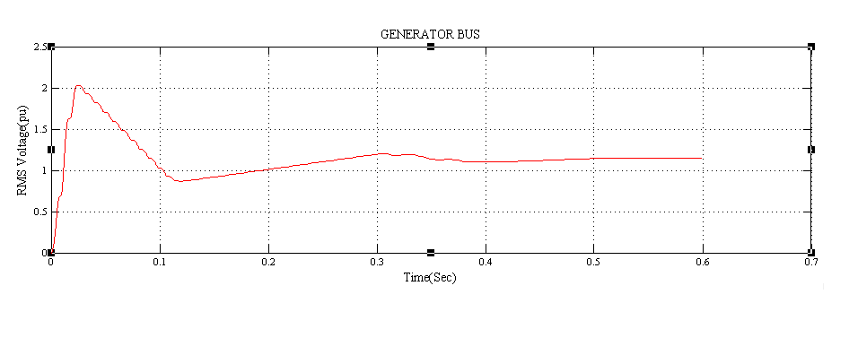 Fig 10.25 The RMS voltage waveform at the generator bus with MPFC
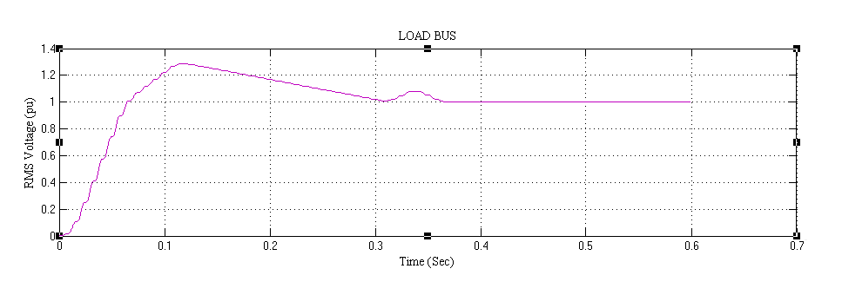 Fig 10.26 The RMS voltage waveform at the load bus without MPFC
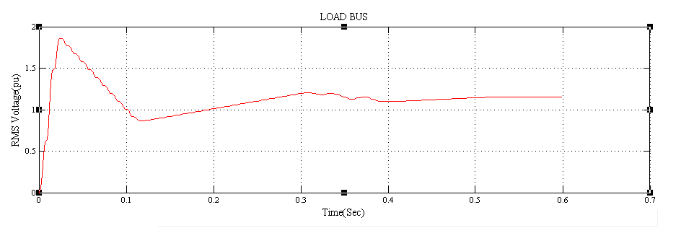
Fig 10.27 The RMS voltage waveform at the load bus with MPFC

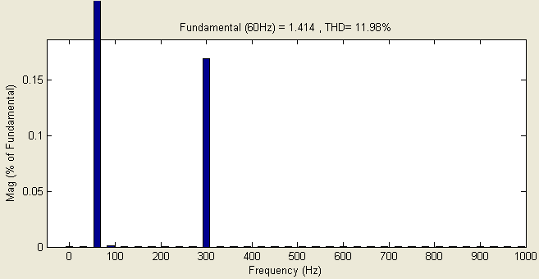
Fig 10.28 THD of Voltage waveforms at load bus without MPFC
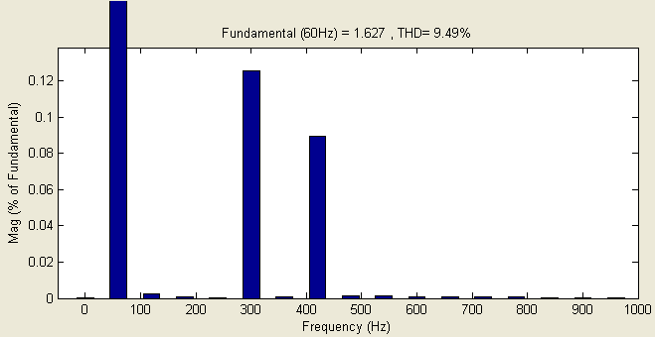
Fig 10.29 THD of Voltage waveforms at load bus with MPFC
.

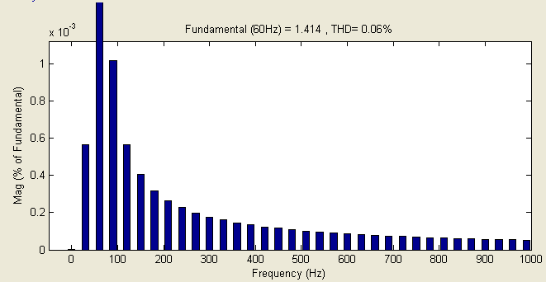
Fig 10.30 THD of Voltage waveform at infinite bus without MPFC

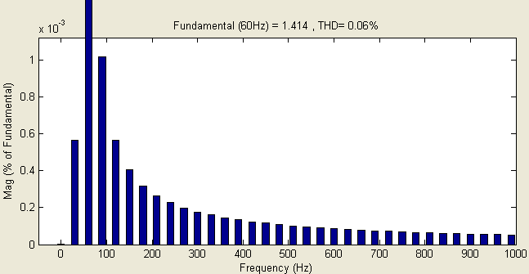
Fig 10.31 THD of Voltage waveform at infinite bus with MPFC
10.8 RESULTS
 |  | P Loss | Q Loss | S Loss
Case 1 | Without MPFC | 0.0832 | 0.1542 | 0.1752
Case 1 | With MPFC | 0.001 | 0.007 | 0.0071
Case 2 | Without MPFC | 0.1954 | 0.3467 | 0.398
Case 2 | With MPFC | 0.001 | 0.007 | 0.0071
Case 3 | Without MPFC | 0.1018 | 0.1869 | 0.2128
Case 3 | With MPFC | 0.0011 | 0.0065 | 0.0066

Table 10.1: The Transmission line losses
XI. CONCLUSIONS AND SCOPE FOR FUTURE WORK
This project presents a novel modulated switched power filter compensator (MPFC) scheme. The MPFC is controlled by a dynamic tri-loop error driven modified PID controller. The digital simulation model of the proposed MPFC scheme has been validated for effective power quality improvement, voltage stabilization, and power factor correction and transmission line loss reduction.
The project can be extended to other distributed or dispersed renewable energy interface and utilization systems and can be easily modified for other specific voltage stabilization and can be used for compensation requirements, and can also be used for the voltage regulation and is used for efficient utilization.

REFERENCE
[1] J. Arrillaga, D. A. Bradley, P. S. Bodge, Power System Harmonics, Wiley, 1985.
[2] D. Daniel Sabin and Ashok Sundaram, “Quality Enhances”, IEEE Spectrum, No. 2, PP. 34-38, 1996.
[3] A.M. Sharaf, Hong Huang, Liuchen Chang," Power quality and nonlinear load voltage stabilization using error-driven switched passive power filter", Proc of the IEEE Inter. Symp. on Industrial Electronics, pp 616-621, 1995.
[4] M. Rastogi , N. Mohan, and A.-A. Edris, “Hybrid-active filtering of harmonic currents in power systems,” IEEE Trans. Power Delivery, vol. 10, no. 4, pp. 1994–2000, Oct. 1995.
[5] H. Fujita and H. Akagi, “Apractical approach to harmonic compensation in power system-series connection of passive, active filters,” IEEE Trans. Ind. Applicat., vol. 27, no. 6, pp. 1020–1025, Nov./Dec. 1991.
[6] A. M. Sharaf, Caixia Guo and Hong Huang, “Distribution/Utilization system voltage stabilization and power quality enhancement using intelligent smart filter”, UPEC’95, England, UK, 1995.
[7] M. Aredes, K. Heumann, and E. H. Watanabe, “An universal active power line conditioner,” IEEE Trans. Power Delivery, vol. 13, no. 2, pp. 545–557, Apr. 1998.
[8] M. Rastogi, N. Mohan, and A.-A. Edris, “Hybrid-active filtering of harmonic currents in power systems,” IEEE Trans. Power Delivery, vol. 10, no. 4, pp. 1994–2000, Oct. 1995.
[9] H. Fujita and H. Akagi , “A hybrid active filter for damping of harmonic resonance in industrial power system,” IEEE Trans. Power Electron., vol. 15, no. 2, pp. 215–222, Mar. 2000.
[10] A. M. Sharaf, and G. Wang, "Wind Energy System Voltage and Energy Enhancement using Low Cost Dynamic Capacitor Compensation Scheme." Proceedings of the IEEE International Conference on Electrical, Electronic and Computer Engineering. pp. 804-807, 5-7 Sept. 2004.

